Current Method of determining the “D” dimension

We currently compute the girder camber at time of slab casting (“D”) based on an “accelerated” construction schedule and a “normal” construction schedule. The accelerated schedule assumes the temporary strands are removed 30 days after prestress transfer and the slab is cast 10 days thereafter, or 40 days after prestress transfer. The normal schedule assumes temporary strand removal at 90 days and slab casting at 120 days after prestress transfer, respectively. This is the time basis for the D₄₀ and D₁₂₀ dimensions giving on the standard girder sheets.

The concept for two levels of girder camber at the time the deck is placed (D₄₀ and D₁₂₀), is to give the contractor the lower and upper bounds of camber that can be anticipated in the field.

For girders without temporary top strands and for non-composite girders, casting of diaphragms and application of superimposed dead loads are substituted for the temporary strand removal and slab casting events, respectively.

Figure 1 depicts the typical input used in our PGSuper program for computing creep and camber. Note that the “A” dimension is based on “D” at 120 days.

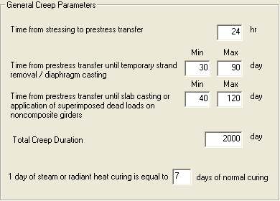
Figure 1 Typical PGSuper input for Creep and Camber Calculations

Figures 2 and 3 illustrate the assumed accelerated and normal construction schedules
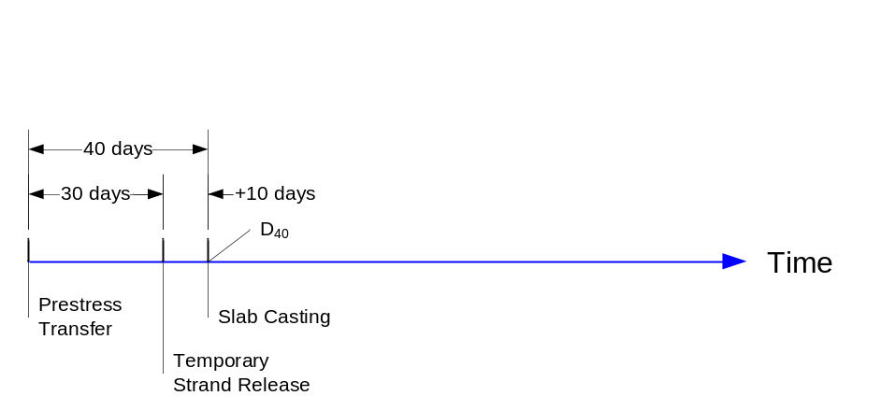
Figure 2 Assumed Accelerated Construction Schedule

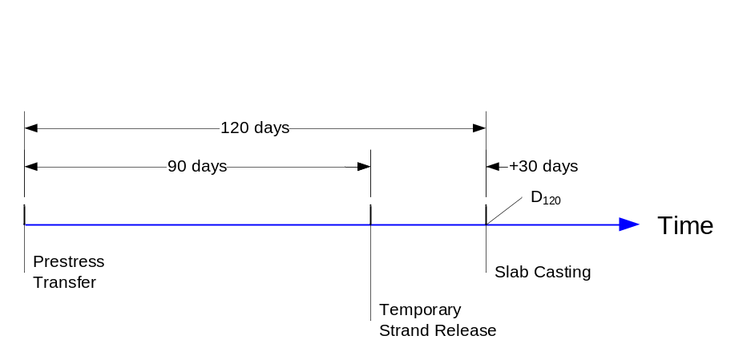
Figure 3 Assumed Normal Construction Schedule

Proposed Changes to “D” dimensions

The construction office has requested, as a result of discussions and cooperation with the AGC, that we provide “D” dimensions for 30, 60, 90, and 120 days after the release of temporary strands. The purpose of providing this information is to give the contractor an estimate of camber growth due to delays in deck placement. To support this request, the following changes will be implemented.

Changes in Camber Calculation Procedures
Acknowledging that calculations are typically done with the aid of the PGSuper computer program, changes in the camber calculation procedures will be describe in terms of changes to the software.

The Creep and Camber parameters will be changed from the Min/Max construction timing currently used to a more robust construction sequencing concept. The Min/Max input columns will be replaced by a grid. Each column in the grid represents an assumed construction sequence. Construction sequences can be added and removed using the Add and Remove buttons. The Slab Offset (“A” Dimension) will be based on one of these construction sequences. A sketch of the conceptual user interface is shown in Figure 4.

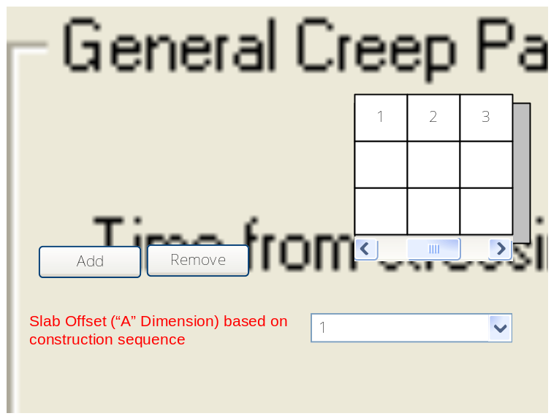
Figure 4 Conceptual Interface for new Creep and Camber Input Parameters

The default input is given in Table 1.

 | Construction Sequences
 | 1 | 2 | 3 | 4 | 5 | 6 | 7 | 8
Time from prestress transfer until temporary strand removal (days) | 30 | 30 | 30 | 30 | 90 | 90 | 90 | 90
Time from prestress transfer until slab casting (days) | 40 | 60 | 90 | 120 | 120 | 150 | 180 | 210
“A” dimension will be based on construction sequence 5.
Table 1 Assumed Construction Sequences

The output from the program will be “D” dimensions for all of the construction sequences. For the default values, “D” dimensions will be computed at 40, 60, 90, and 120 days after temporary strand removal for temporary strands removed at 30 days after prestress release and 120, 150, 180, and 210 days for after temporary strand removal for temporary strand removed at 90 days after prestress release.

In a nutshell, the current creep and camber computations will be performed with more timing combinations.

Changes to Standard Girder Sheets
The number of “D” dimensions given on the plan sheets will increase from 2 to 8 per girder. In order to accommodate this, it is recommended that the D @ 40 DAYS and D @ 120 DAYS columns be removed from the GIRDER SCHEDULE and a new CAMBER SCHEDULE be added. The CAMBER SCHEDULE will be similar to that shown in Figure 5.

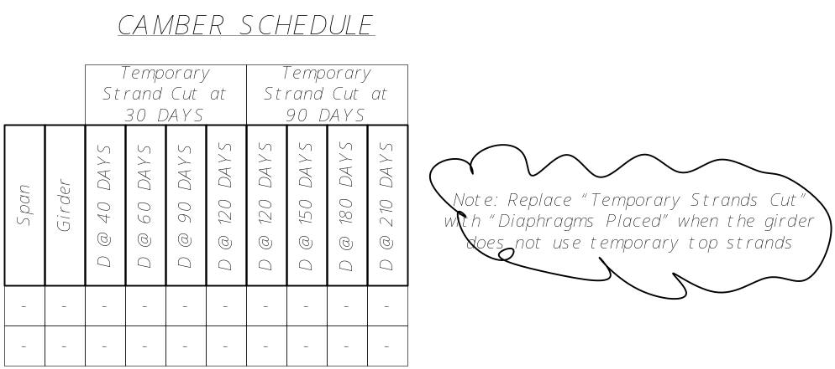
Figure 5 Proposed Camber Schedule

Changes to the Bridge Design Manual
Section 5.2.6 of the BDM should be updated to include a discussion of why we have two assumed construction schedules and why eight “D” dimensions are computed.

